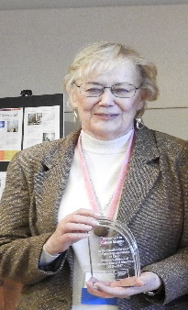

Coleen Magera Children’s Champion Award Nomination Form

The Coleen Magera Children’s Champion award is a platform to recognize the outstanding accomplishments of professionals working as part of a multidisciplinary team in Montana.
Any professional can make a nomination. Any professional can make multiple nominations.
Nominations can be made for:

- an individual professional (Law Enforcement, CPS, VA, Prosecutor, FI, Medical or MH)
- a group of MDT professionals – multiple professionals who collaborated on a case.
- A multidisciplinary team

The deadline for nominations is January 20, 2023. Nominee’s will be notified by February 1, 2023.

Please email nominations to Brenda George – director@childrensalliancemt.org

Coleen Magera was a leader and a true champion for children in Montana. Coleen was a founding member of the Children’s Alliance of Montana. She served on the board from 2008 through 2019. She was the County Attorney in Powder River, Custer and Sanders Counties. She founded Sarah’s Place Child Advocacy Center in Sanders County in 2008. Coleen was an exemplary leader who promoted the best interest and professionals working together as a team. She was also an aggressive prosecutor committed to holding offenders accountable.

Nominee #1 Name
Job Title (if applicable for MDT nomination please list the CAC Director or MDT Coordinator)
Contact email
Nominee #2 Name
Job Title
Contact email
Nominee #3 Name
Job Title
Contact email
Nominee #4 Name
Job Title
Contact email
Nominee #5 Name
Job Title
Contact email
Nominated by
Job Title

Nomination text:
- List outstanding actions for the nomination.
- Provide as much information as possible and describe the collaboration with other professionals or the teamwork that was involved.
- Try to avoid jargon. While you may be familiar with the nominee's work, others may not; with this in mind, describe the nature and quality of the contributions and accomplishments.
- Your narrative will likely be read aloud to the recipient and audience. Use appropriate grammar and English.

Please use the space (or additional page) below to describe your reasons for this nomination. Be as detailed as possible.

Funds to honor Coleen and underwrite this award have been provided by Coleen’s loving husband – Rich Magera; and a few of her dear friends – Linda and Frank G. Polster, III; and Carl and Denise Benson. Thank you to these supporters for your kindness and generosity.

