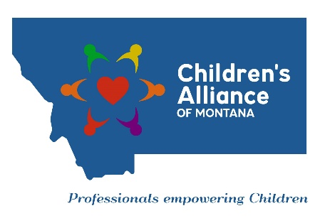
Job Announcement – Membership and Project Coordinator – Children’s Alliance of Montana

The Children's Alliance of Montana (CAM) is seeking a dynamic and committed professional to join our team! We are currently seeking a Membership and Project Coordinator. This position will be responsible for working closely with the Executive Director on membership services and coordination of state-wide projects.

This position is grant funded and is contingent upon the availability of grant funds. Other duties will include grant reporting, tracking grant and training activities, and preparing evaluations of trainings and services to ensure member satisfaction and learning objectives are met.

Candidates should have strong written and verbal communication skills, and a working knowledge of all Microsoft office software applications (i.e., Word and Excel). Experience with social media and website development and/or management is a plus.

This position involves 25% travel within the state. Some out-of-state travel may be required. Candidates must have a valid drivers’ license, proof of automobile insurance, and pass a criminal background check and child abuse registry check.

Our office is currently located in Billings. However, telecommuting may be considered. Benefits and a competitive hourly rate will be offered. The hourly rate ranges from $14 to $18 per hour based on experience. This is not a salaried position. Bachelor’s degree in a human service or business-related field, or the equivalent in work experience is required.

If you or someone you know is interested in applying for this position, please send a resume with 3 professional references, a cover letter, and a written response to the question below via email to Brenda George at director@childrensalliancemt.org by 5:00 p.m. MDT, Monday, October 28, 2019.
Candidates please submit:
1. Resume with 3 professional references
2. Cover letter
3. Written response to the following question: “How would your current or most recent supervisor describe your ability to get along with others including co-workers, supervisors, and the general public?”

Incomplete or late materials may not be considered. Applicants who require special accommodation due to disability should contact Brenda George at 406-672-2136. If this position becomes available within 90 days, the same applicant pool may be considered.

For a copy of the full job description, please visit our website at www.childrensalliancemt.org

