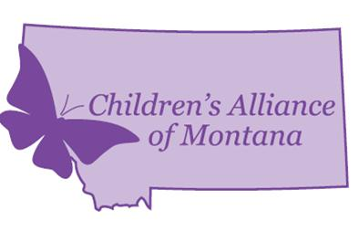
CONTACT: Brenda George,
Executive Director, CAM
(406) 672-2136
director@childrensalliancemt.org

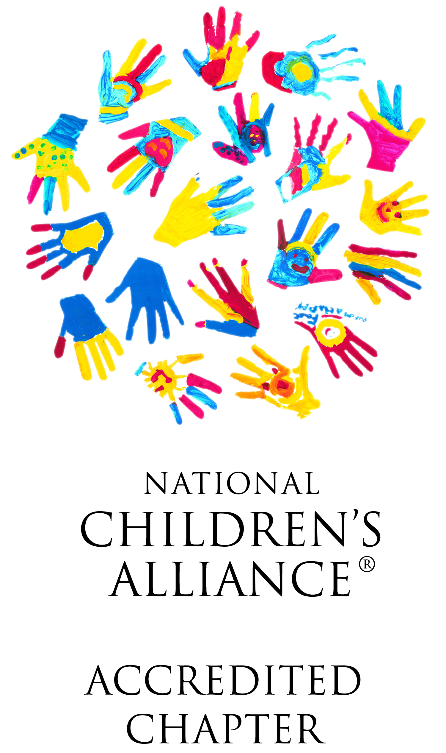

FOR IMMEDIATE RELEASE

Children’s Alliance of Montana Advisory Board Member
and Montana Department of Justice Employee Dana Toole Receives National Award
from the National Children’s Alliance

At the annual National Children’s Alliance Leadership Conference in Washington, DC in June, Dana Toole, Bureau Chief of the Children’s Justice Bureau at the Montana Department of Justice, received national recognition for her achievements in developing and supporting Children’s Advocacy Centers (CAC) and Multidisciplinary Teams (MDT) across Montana. Toole received the Horowitz-Barker Lifetime Achievement Award, which recognizes a professional who has demonstrated, over the course of a career, a dedication to the CAC movement and a strengthening of the CAC model. Award qualifications also require leading by example and demonstrating the spirit of collaboration that is the hallmark of MDT work.

“Dana’s been on the front lines of one of the most important battles we face at the Montana Department of Justice, which is ensuring that all of our youngest citizens have safe and healthy childhoods,” said Attorney General Tim Fox. “Dana’s dedication to improving the response to crimes against children and ensuring that justice prevails for these vulnerable victims is nothing short of remarkable. We’re delighted Dana’s efforts have received national recognition; she is certainly most deserving of this honor.”

Toole began her career as a licensed clinical social worker. She was the founding Director of the Lewis and Clark County CAC in Helena, the second CAC to be accredited by the National Children’s Alliance (NCA) in Montana over a decade ago. Toole is a founding member of the Children’s Alliance of Montana, the NCA Accredited State Chapter organization of CACs. “Dana is influential, inspirational, and a strong advocate for the work, influence and mentoring opportunities of the Chapter,” said Brenda George, Executive Director of the Children’s Alliance of Montana.

In 2009, Toole became coordinator for the Montana Child Sexual Abuse Response Teams (MCSART) Program at the Montana Department of Justice. With a mission to expand MDTs and CACs, Toole set out to equip interview rooms, provide training, and promote CACs. Toole later became the Bureau Chief of the Children’s Justice Bureau at the Montana Department of Justice.

Toole has mentored professionals in every Montana county and Tribe. Brenda George added, “Thanks to Dana, Montana has seven accredited CACs, seventeen developing CACs, four of which are Tribal CACs; three additional CACs have accreditation applications pending with NCA, and numerous active MDTs.”

Toole also developed child forensic interview training and promotes forensic interview peer review. Her bureau provided start-up funding to developing CACs, on-site technical assistance and mentoring. Toole has also advocated for bringing national-level training to Montana and has prioritized evidence-based, trauma training for mental health professionals, reaching over 250 mental health professionals and a total of approximately 3,000 professionals.

Bryan Lockerby, Administrator of the Division of Criminal Investigation at the Montana Department of Justice, said, “Dana has worked closely with the FBI to ensure that CACs would serve all Montana’s children. She’s also collaborated with tribal and federal agencies to provide training and develop CACs. Her career has been dedicated to ensuring that children are heard, professionals are supported and well-trained, and that offenders are held accountable.”

For more information, contact Brenda George, Executive Director of the Children’s Alliance of Montana at (406) 672-2136 or by email at director@childrensalliancemt.org..

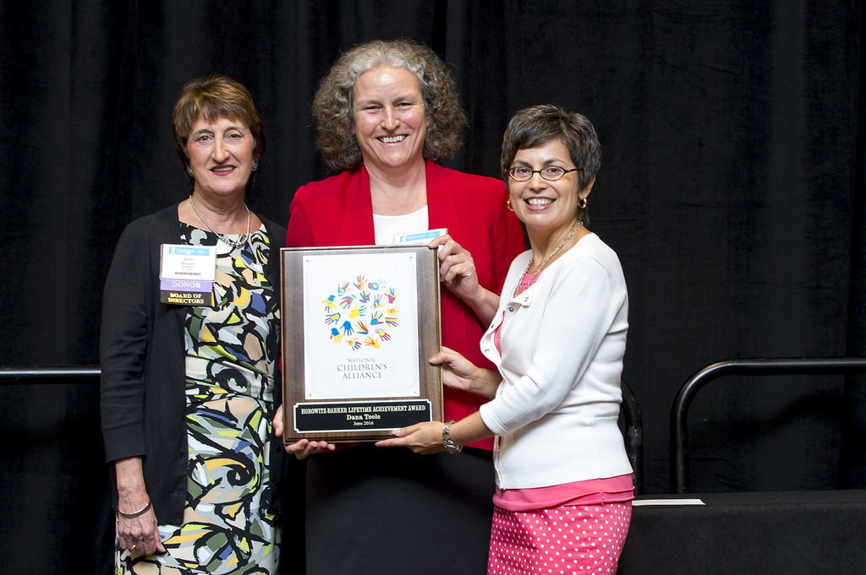

Beth Brandes, President, National Children’s Alliance Board of Directors; Dana Toole, Bureau Chief, Children’s Justice Bureau, Montana Department of Justice; and Teresa Huizar, Executive Director, National Children’s Alliance

National Children’s Alliance is the accrediting body for more than 770 Children’s Advocacy Centers serving all 50 states and the District of Columbia. Dedicated to helping local communities respond to allegations of child abuse in ways that are efficient and effective, National Children’s Alliance provides support and advocacy to its accredited membership, developing centers, multidisciplinary teams, and child abuse professional around the world.

As the national authority on multidisciplinary approaches to supporting child victims of abuse, the purpose of National Children’s Alliance is to empower local communities to provide comprehensive, coordinated and compassionate services to victims of child abuse. Learn more by visiting www.nationalchildrensalliance.org.

-END-

